LAB MANUAL #6
Objectives:
- To learn and understand the working of NAND gate and NOR gate
NOTE:
- Implement the questions on logic works where it is mentioned.
- Only perform the part (a) & part (b) in question 2 & 3 using ICs (codes are mentioned below). Remaining part & question 3 can be performed using ready-made blocks.

Introduction to NAND Gate
74LS00 IC contains four 2-input NAND gates. The function table and connection diagram for this IC are shown below:
Function Table Connection Diagram:
Inputs |  | Output
A | B | Y
L | L | H
L | H | H
H | L | H
H | H | L
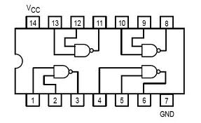
H= Logic High, L= Logic Low

Introduction to NOR Gate
74LS02 IC contains four 2-input NOR gates. The function table and connection diagram for this IC are shown below:
Function Table: Connection Diagram:

Inputs |  | Output
A | B | Y
L | L | H
L | H | L
H | L | L
H | H | L
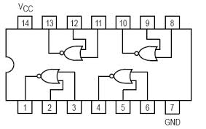
H= Logic High, L= Logic Low

Question #1:
Simplify the Product-Of-Sums Boolean expression below.
NOR and NAND Implementation on logic trainer:

Question#2:
Implement on Logic Works the following using only the NAND gates
- Z = A.B (b) X = A+B (c) XNOR
Note: Implement only part (a) & (b) using ICs

Question#3:
Implement on Logic Works the following using only the NOR gates.
- Z = A.B (b) X = A+B (c) XOR

Note: Implement only part (a) & (b) using ICs

Question # 4: For the Boolean function $F1(A,B,C,D)=\sum{m(2,4,12,14)}$ do the following:
- Find truth table
- Find minimal SOP expression for Boolean function $F1$ using K-map. Draw K-map.
- Draw the resultant expression obtained in part (b) and implement on Logic Works using only NAND gates.

